<!DOCTYPE html>

<html>

<head>

    <title>Forms</title>

</head>

<body>

    <h1>Login Form</h1>

    <Form>

        <label for="Username">Username:</label>

        <input type="text" required><br><br>

        <label for="Password">Password:</label>

        <input type="password" required><br><br>

        <input type="submit" value="Login">

    </Form>

</body>

</html>

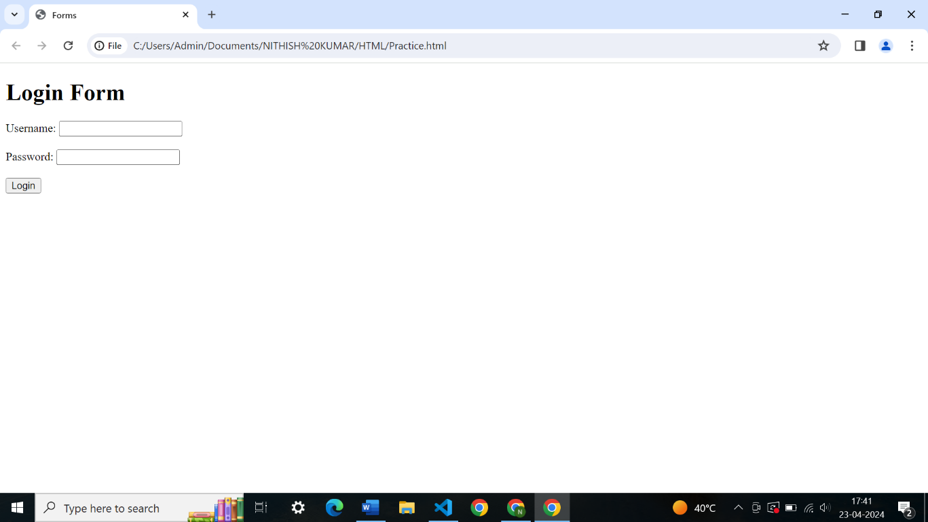

<!DOCTYPE html>

<html>

<head>

    <title>Forms</title>

</head>

<body>

    <h1>Registration Form</h1>

    <Form>

        <label for="Firstname">Firstname:</label>

        <input type="text"><br><br>

        <label for="Lastname">Lastname</label>

        <input type="text"><br><br>

        <label for="Gender">Gender:</label>

        <label for="Gender">Male:</label>

        <input type="radio">

        <label for="Gender">Female:<label>

        <input type="radio"><br><br>

        <label for="email">Email:</label>

        <input type="email" name="Email" required><br><br>

        <label for="password">Password:</label>

        <input type="password" required><br><br>

        <label for="Address">Address:</label>

        <input type="text" name="Address"><br><br>

        <input type="checkbox" name="check">

        <label for="Accept">Accept</label><br><br>

        <input type="submit">

        <input type="button" name="cancel" value="Cancel">

    </Form>

</body>

</html>

